C110FMDQ(Na), WQA/NSF-44&&61 Certified
SOLVENT-FREE (BY STEAM-RINSE) STRONG ACID CATION EXCHANGE RESIN
(Designed for use in water softening applications)

Product Description

C110FMDQ(Na) resin is a high-capacity, conventional gel polystyrene strong acid cation exchange resin designed for use in residential or industrial water softening equipment. Cation resin in sodium form removes hardness ions such as calcium and magnesium by replacing them with sodium. When the resin bed is exhausted the hardness ions begin to pass through the bed. Functionality is returned by regeneration with concentrated sodium or potassium chloride solution. The capacity obtained depends largely on the amount of salt used in the regeneration. Typically 12-15 lbs of chemical per ft3 is used to obtain maximum capacity of up to 35,000 grains per ft3 (claim not tested/certified by WQA).

C110FMDQ(Na) resin is rigorously treated before shipping to meet all NSF-44 standards requirements.

Typical Physical, Chemical & Operating Characteristics

Polymer Structure | Polystyrene cross linked with a minimum of 10% Divinylbenzene
Physical Form and Appearance | Amber spherical beads
Whole Bead Count | 90% Min.
Functional Groups | Polystyrene sulfonate
Ionic Form (as shipped) | Na+
Shipping Weight, approx. | 830 g/l (53 lb./ft.³)
Mesh Size (U.S. Std.) | 40-70
Moisture retention, Na+ form | 45–48%
Swelling, Na+—>H+ | 5% max.
Total Capacity in sodium form | 2.05 meq/ml (claim not tested/certified by WQA)
pH Range, Stability | 0–14
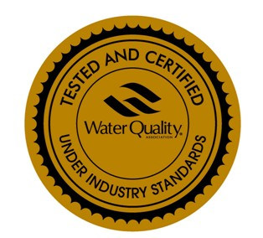
CHEMI CAL AND THERMAL STABILITY

C110FMDQ(Na) resin is insoluble in dilute or moderately concentrated acids, alkalies, and in all common solvents. However, exposure to >0.5 ppm of free chlorine, “hypochlorite” ions, or other strong oxidizing agents over long periods of time will eventually break down the crosslinking. Temperature over 30 ºC (85 ºF) will accelerate the oxidation. This will tend to increase the moisture retention of the resin, decreasing it s mechanical strength, as well as generating small amounts of extractable breakdown products. Like all conventional Polystyrene sulfonated resins, it is thermally stable to higher than 160 ºC (320 ºF) in the alkali (for instance, sodium) or alkaline earth (calcium and magnesium) salt forms. The free acid form tends to hydrolyze in water temperatures appreciably higher than 130 ºC (270 ºF) thereby losing capacity, as the functional groups are gradually replaced by hydroxyl groups.
Product has been tested and certified by WQA according to NSF/ANSI 44 and NSF/ANSI 61 for material safety requirements only

