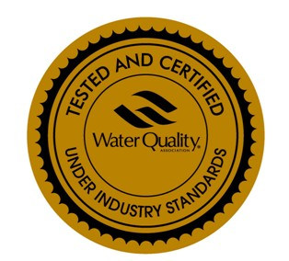
C107UPDQ (Na), WQA Certified to NSF/ANSI 44 & 61
DRINKING-WATER QUALITY UNIFORM PARTICLE-SIZE STRONG ACID CATION EXCHANGE RESIN
(Designed for use in water softening applications)
Product Description

C107UPDQ(Na) resin is a high-capacity, conventional gel polystyrene strong acid cation exchange resin designed for use in residential or industrial water softening equipment. Cation resin in the sodium form removes hardness ions such as calcium and magnesium by replacing them with sodium. When the resin bed is exhausted the hardness ions begin to pass through the bed. Functionality is returned by regeneration with concentrated sodium or potassium chloride solution. The capacity obtained depends largely on the amount of salt used in the regeneration. Typically 15 lbs of sodium chloride per ft3 is used to obtain maximum capacity of up to 32,000 grains per ft3. (claim not tested/certified by WQA)
C107UPDQ(Na) resin is also capable of removing in the same way dissolved iron, manganese, and also suspended matter by virtue of the filtering action of the bed. C107UPDQ(Na) is specially and rigorously treated to meet NSF-61 and NSF-44 requirements.
Typical Physical, Chemical & Operating Characteristics
Polymer Structure | Polystyrene 7% cross linked with  Divinylbenzene
Physical Form and Appearance | Uniform-size amber spherical beads
Whole Bead Count | 90% Min.
Functional Groups | Polystyrene sulfonate
Ionic Form (as shipped) | Na+
Shipping Weight, approx. | 810 g/l (50 lb./ft.³)
Mesh Size (U.S. Std) – Uniform particle size range | Available range: 16-30 mesh, 24-40 mesh, 40-70 mesh, etc.
Uniformity | <1.25
Moisture retention, Na+ form | 46–51%
Swelling, Na+—>H+ | 5% max.
Total Capacity in sodium form | 1.90 meq/ml (claim not tested/certified by WQA)
pH Range, Stability | 0–14

CHEMI CAL AND THERMAL STABILITY

C107UPDQ(Na) resin is insoluble in dilute or moderately concentrated acids, alkalies, and in all common solvents. However, exposure to >0.1 ppm of free chlorine, “hypochlorite” ions, or other strong oxidizing agents over long periods of time will eventually break down the crosslink. Temperature over 30 ºC (85 ºF) will accelerate the oxidation. This will tend to increase the moisture retention of the resin, decreasing it s mechanical strength, as well as generating small amounts of extractable breakdown products. Like all conventional Polystyrene sulfonated resins, it is thermally stable to higher than 150 ºC (300 ºF) in the alkali (for instance, sodium) or alkaline earth (calcium and magnesium) salt forms. The free acid form tends to hydrolyze in water temperatures appreciably higher than 120 ºC (250 ºF) thereby losing capacity, as the functional groups are gradually replaced by hydroxyl groups.

Product has been tested and certified by WQA according to NSF/ANSI 44 and NSF/ANSI 61 for material safety requirements only

